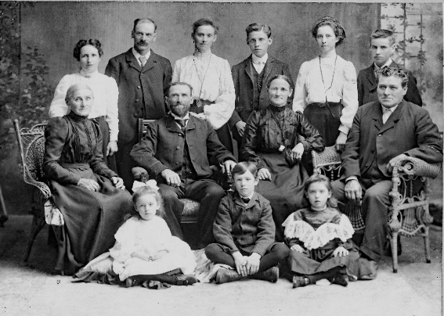 |  | 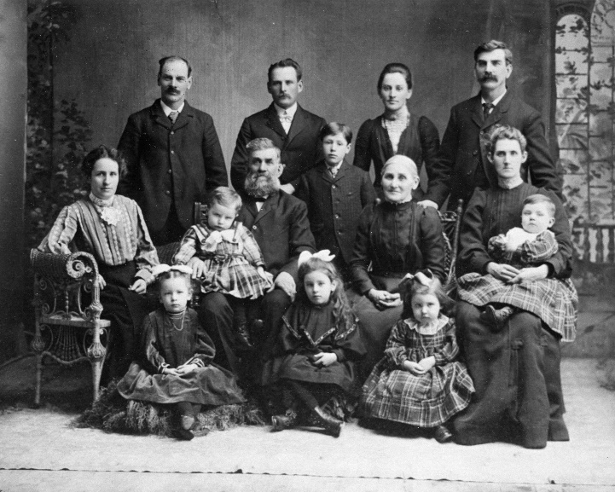
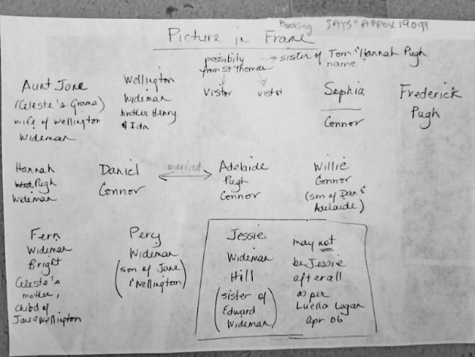 |  | 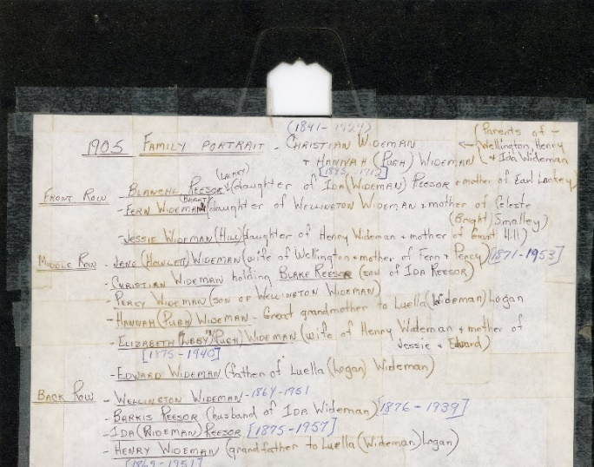
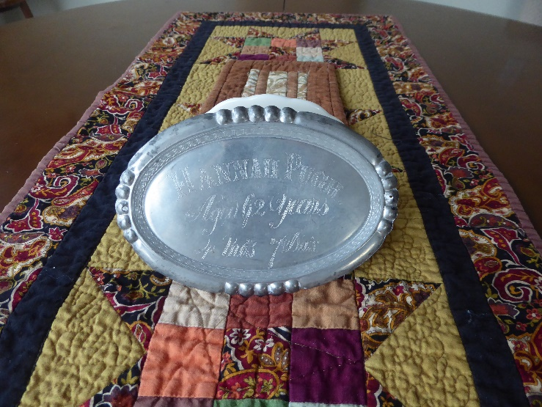 |  | 
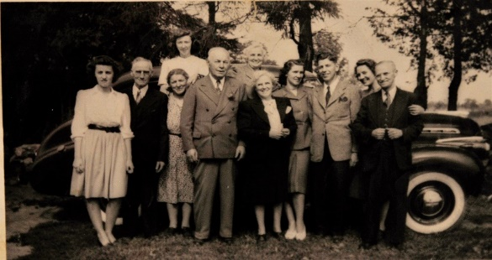 |  | 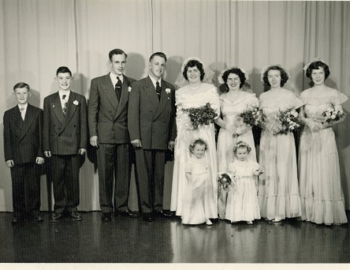
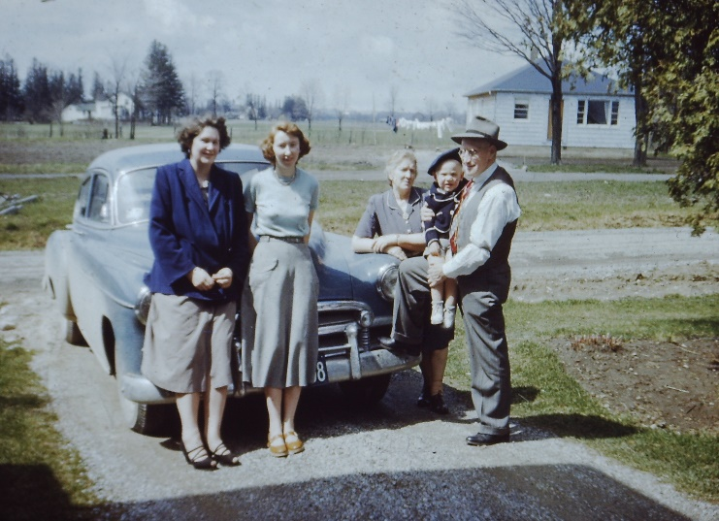 |  | 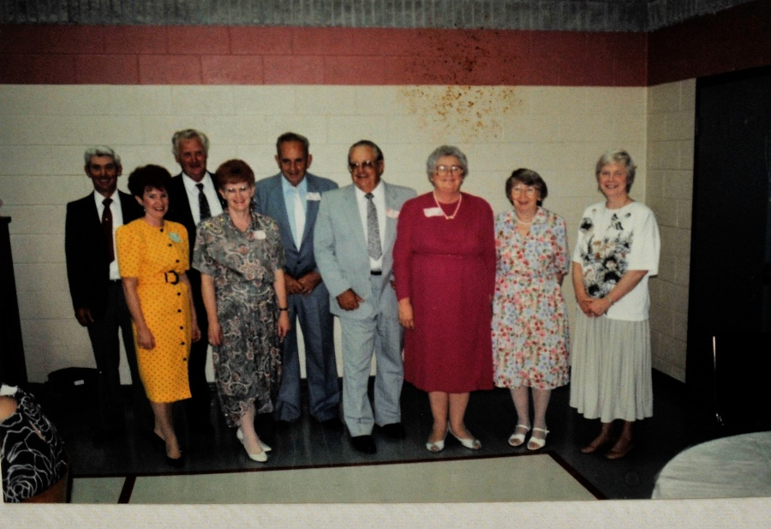
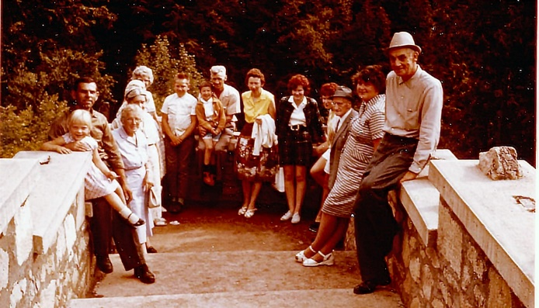 |  | 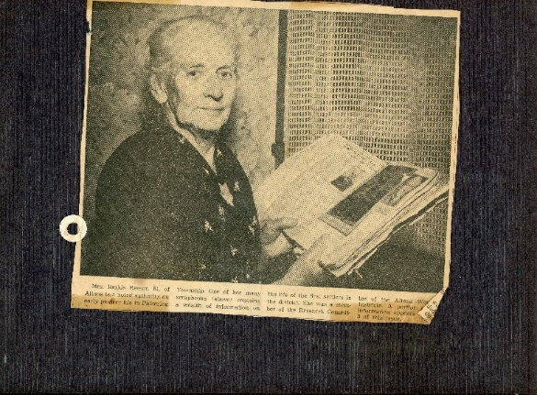
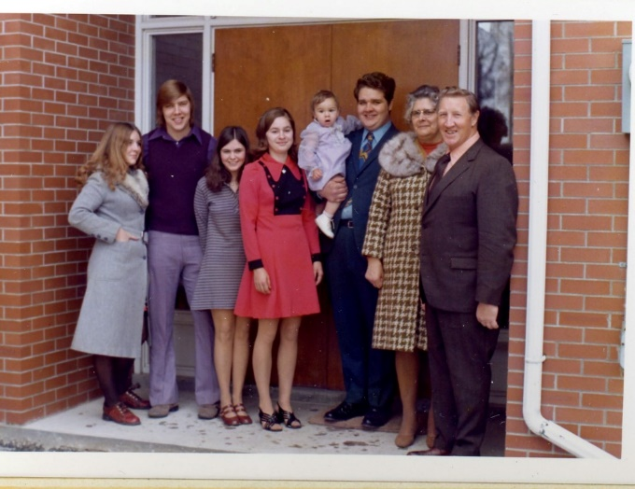 |  | 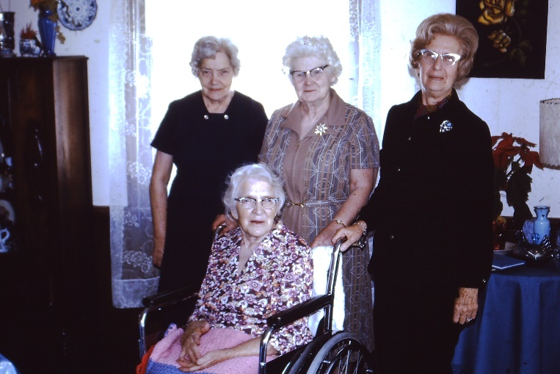
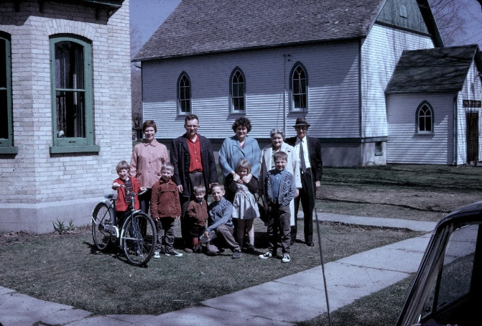 |  | 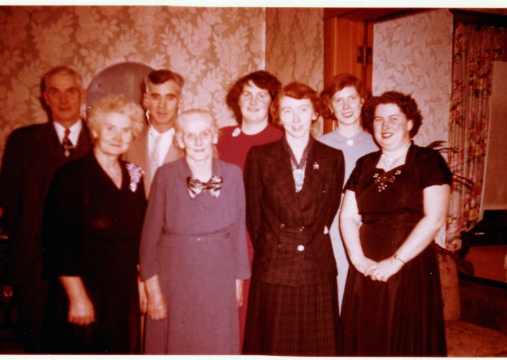
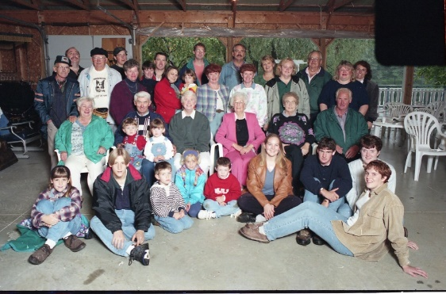 |  | 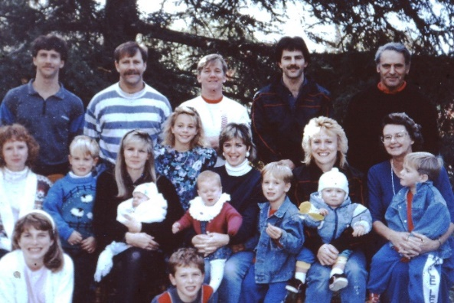
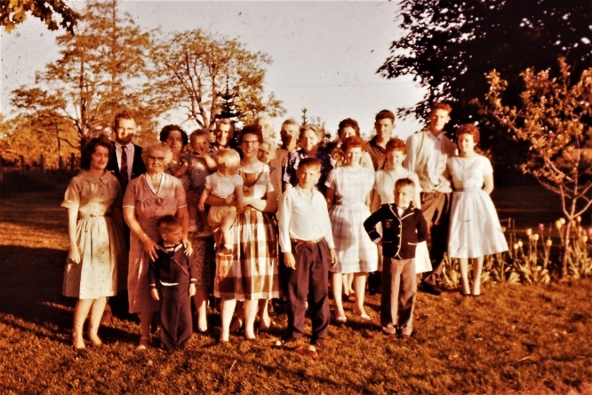 |  | 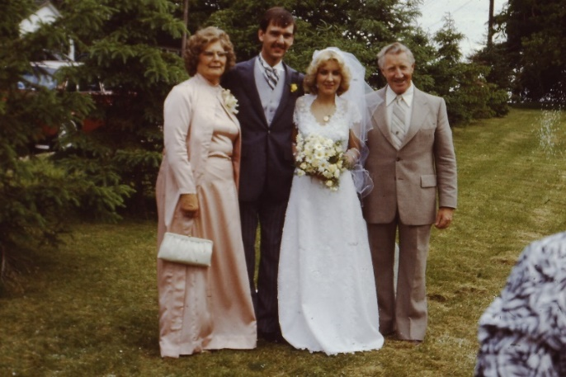
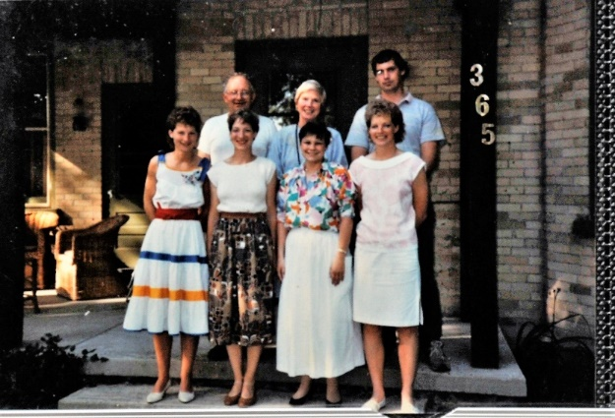 |  | 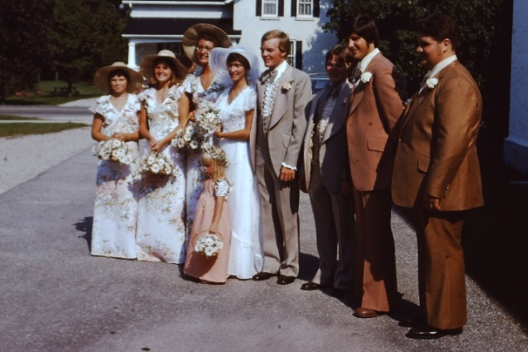
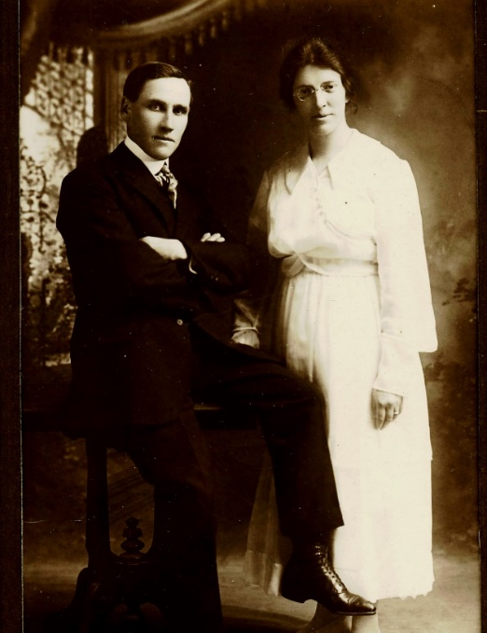 |  | 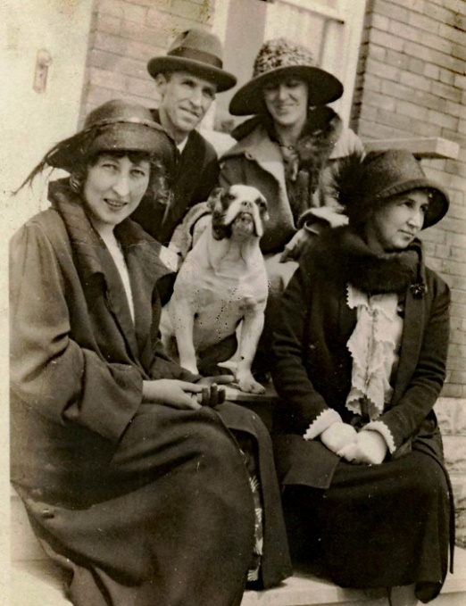


"Wideman Pugh Family Reunion
September 14, 2024
the Goodwood community Centre
at 268 Durham Road Highway 47, Goodwood Ontario.
The day begins at 11 AM with the displays all family members. At 1230 there will be pot luck lunch. At 130 will be the family and friends photo. The rest of the day will be visiting and catching up with each other. The day will end 4:45 PM
As you know this it will be a pot luck lunch main course and Dessert, drinks will be provided no alcohol.
We ask you to bring your hobbies, craft and memorabilia to display tables also if you have a talent.
If you have an outdoor game that people can play please make us aware of so we can set up again.
There will be a free will Offering to cover expenses. (Rental, Drinks, Decorations)
The details should be on the Wideman Pugh website (Place4U2go.ca) that you can check in with other family members reminding them of the day the formal invite you can respond to the website which will
keep us informed on how many are coming please communicate with other family members and tell them how to respond to this day so we can plan appropriately.
if you would like to help please respond on website also please fill out the questionnaire so that
we can better plan for the event launching in travel information can be provided also on
the website if you want to add additional pictures you cannot load them or send to the address at
the bottom of the webite.

